**Sonarqube installation and configuration**

**Sonarqube Requirements**:

1. JDK 11(<https://www.oracle.com/java/technologies/javase-jdk11-downloads.html>)
2. Sonar-qube(<https://www.sonarqube.org/downloads/>)
3. Sonar-Scanner(<https://docs.sonarqube.org/latest/analysis/scan/sonarscanner/>)

If we have the above files then keep all the files in one folder for your convenience.

**How to Set JDK 11 Path:**

1. Download the JDK 11 Zip file from <https://www.oracle.com/java/technologies/javase-jdk11-downloads.html> Scroll down to this site and you can see as [jdk-11.0.7_windows-x64_bin.zip](https://www.oracle.com/java/technologies/javase-jdk11-downloads.html#license-lightbox) and click download(It will ask Sign in to Oracle – Sign in to Oracle) the moment you sign in it will get downloaded JDK 11 **then you need Extract the JDK 11 to the current folder**

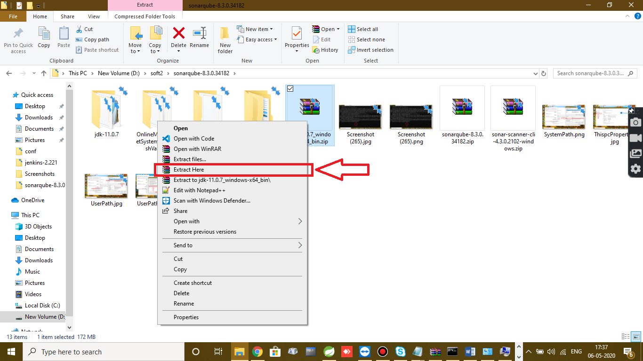

1. Open the folder of jdk 11 then go to bin folder
2. Copy the path as shown

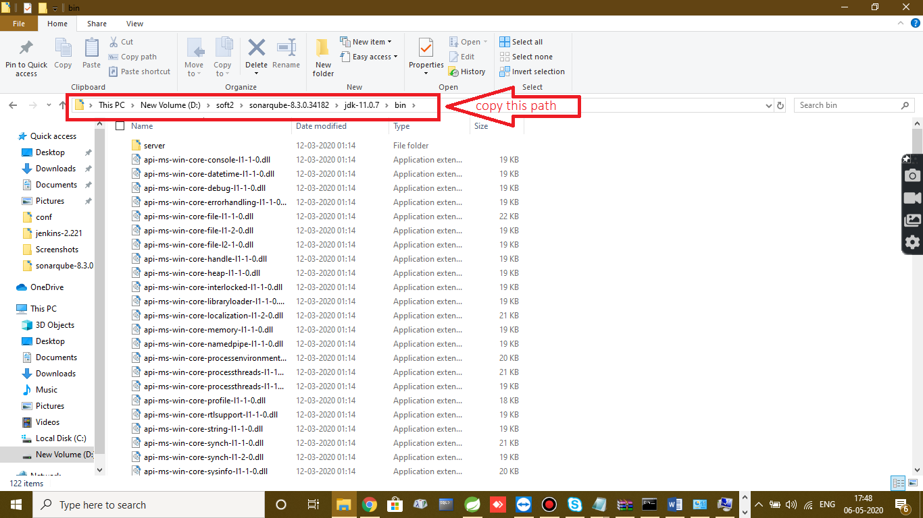

1. Set the path of JDK 11 to do that Right click of This PC> Properties

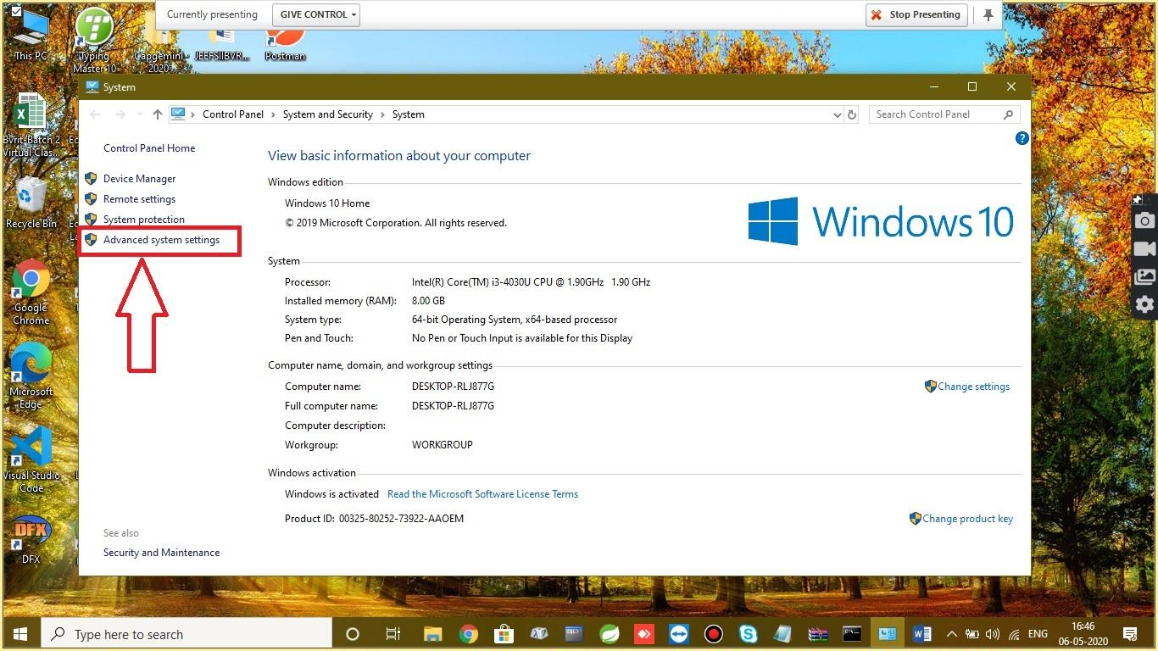

1. Go to Advanced system settings and select Environment Variables and then select the User Variables Path as shown and then click edit

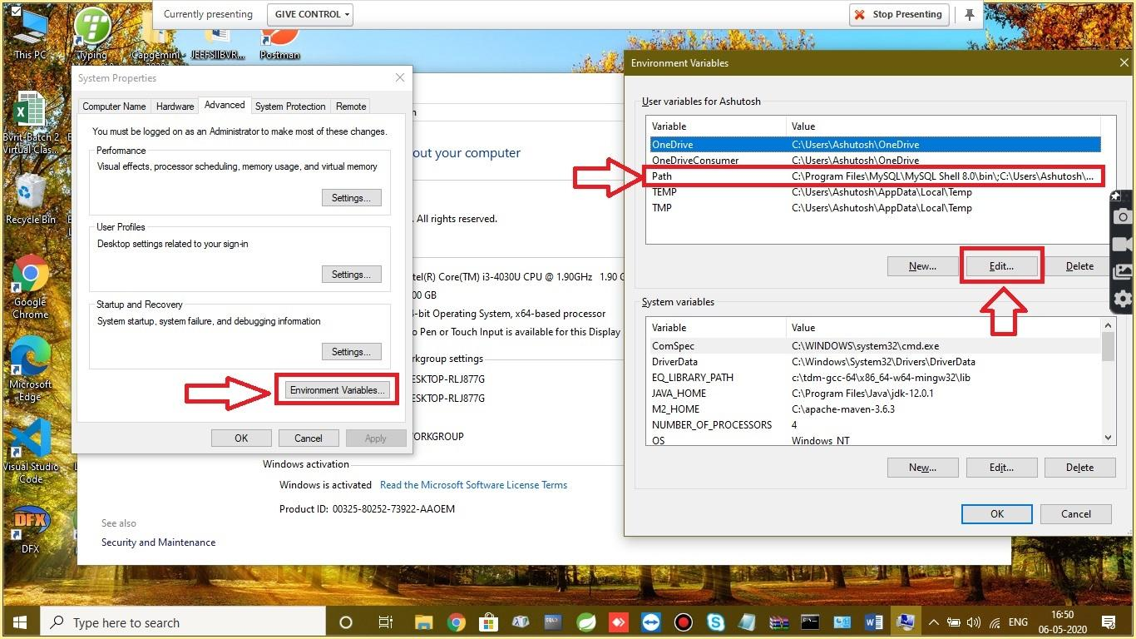

1. After clicking edit then you can see the below dialog box as edit environmental variables. In “Edit Environmental Variables” select New and Paste the path as shown then click ok

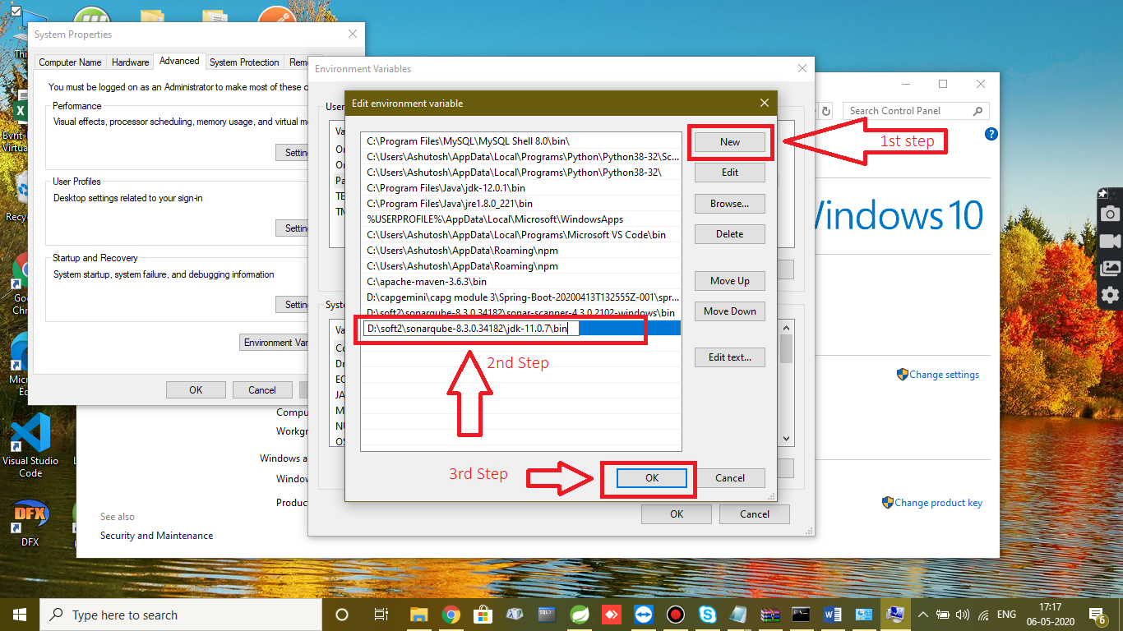

1. Copy **the same path in System variable** box also. In System Variable select the path Click Edit>New> Paste the path

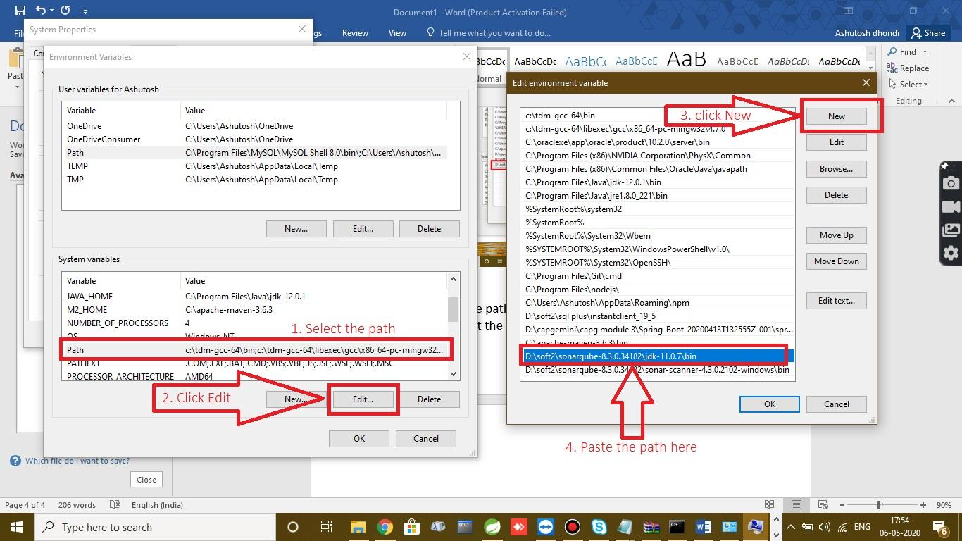

Now we are done with JDK 11 Path setting ☺

**We need to set the path of the Sonar-Scanner in a same way**

1. Go to the Sonarqube scanner folder then go to bin folder and copy the path.

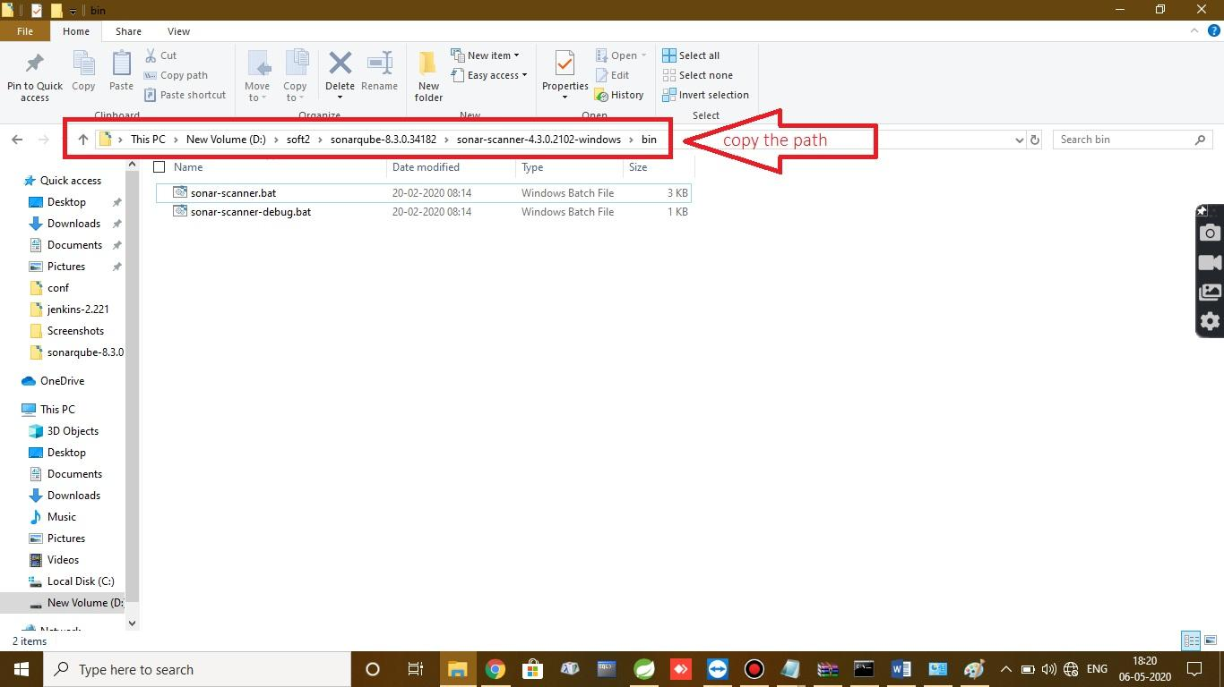

1. Right Click of This PC> Advance System Settings> Environment Variables. After clicking Environmental variables in **User variable**table select Path and click Edit

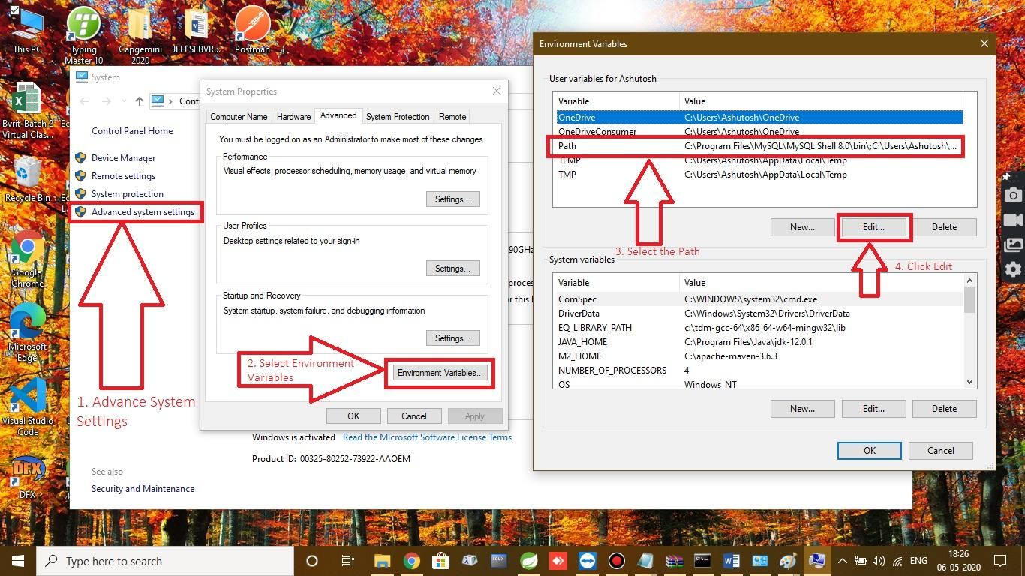

1. Click New and paste the path and then click ok

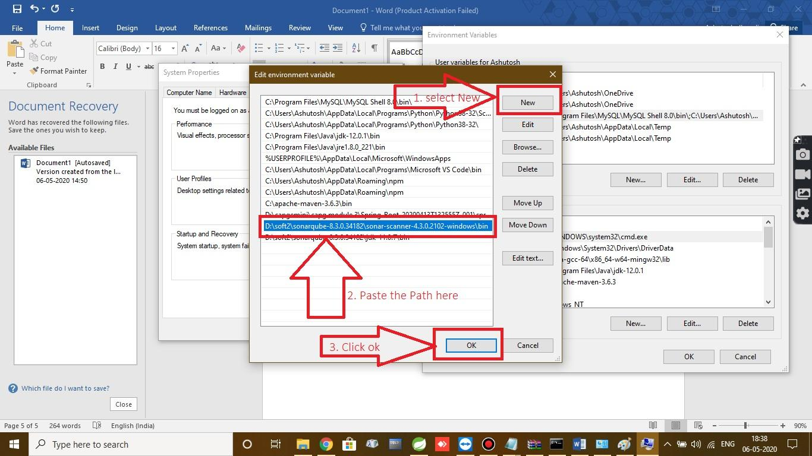

1. We need to copy the path in **System variables** also, In System Variables select Path and click on Edit then click New and paste the Path as shown.

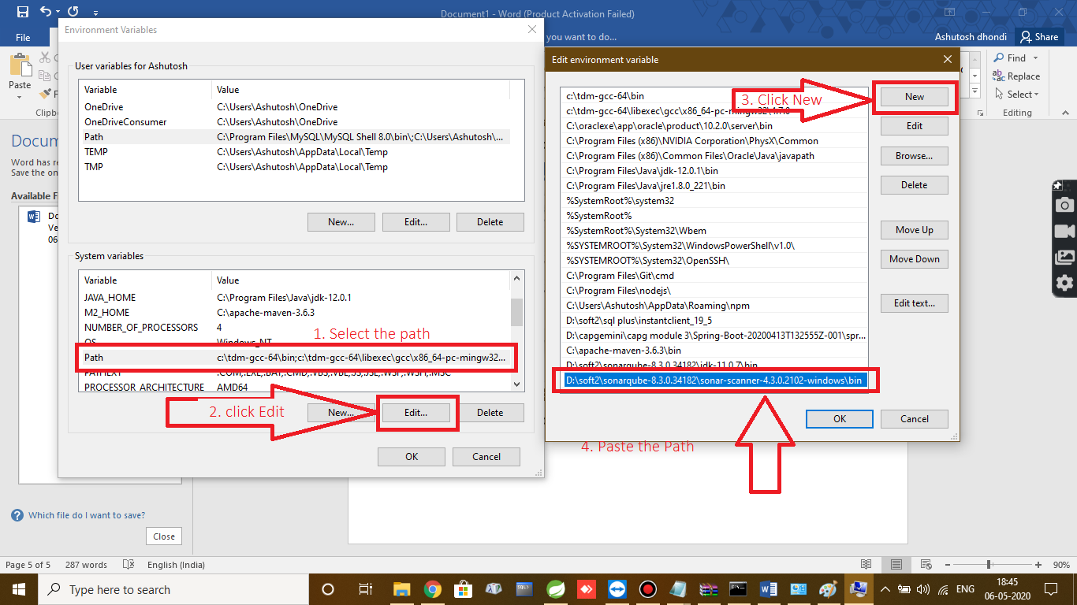

Now we are done with sonar-scanner path setting ☺

**How to Run the Sonarqube?**

1. Open the sonarqube-8.3.0.34182\sonarqube-8.3.0.34182\bin\windows-x86-64.
2. Click StartSonar.bat

Note: If you get Java 11 is not available then go to Environment variables, select that jdk 11 path, On the right side there is a move up button, move up to the first

1. After completion of running startsonar.bat then it should show sonar is up as shown below

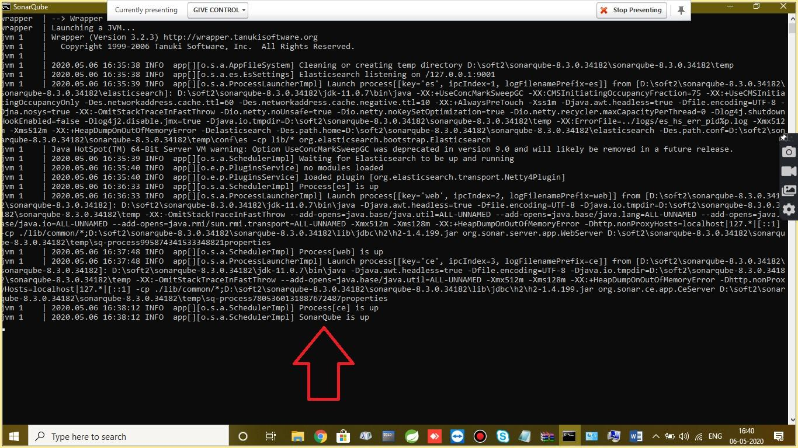

1. Open the browser, In URL type “localhost:9000” then the sonarqube opens
2. It will ask the login credentials type Username as admin and password as admin
3. Once you login into the sonar then you are done with launching the sonar ☺

**To Check the Quality of your Project in sonar:**

1. Open your project in STS/eclipse and add the following dependencies in the pom.xml

<dependency>

<groupId>org.jacoco</groupId>

<artifactId>jacoco-maven-plugin</artifactId>

<version>0.8.5</version>

</dependency>

<!-- https://mvnrepository.com/artifact/org.sonarsource.scanner.maven/sonar-maven-plugin -->

<dependency>

<groupId>org.sonarsource.scanner.maven</groupId>

<artifactId>sonar-maven-plugin</artifactId>

<version>3.6.0.1398</version>

</dependency>

1. Add the profile after the </Dependencies> tag closes. Ensure that you have added the profiles outside the </Dependencies> tag (Very important)

<profiles>

<profile>

<id>sonar</id>

<activation>

<activeByDefault>true</activeByDefault>

</activation>

<properties>

<!-- Optional URL to server. Default value is http://localhost:9000 -->

<sonar.host.url>

http://localhost:9000

</sonar.host.url>

</properties>

</profile>

</profiles>

1. Right click of your project then click properties.
2. Once you click the properties you will see as shown in fig. click the small symbol as shown in fig

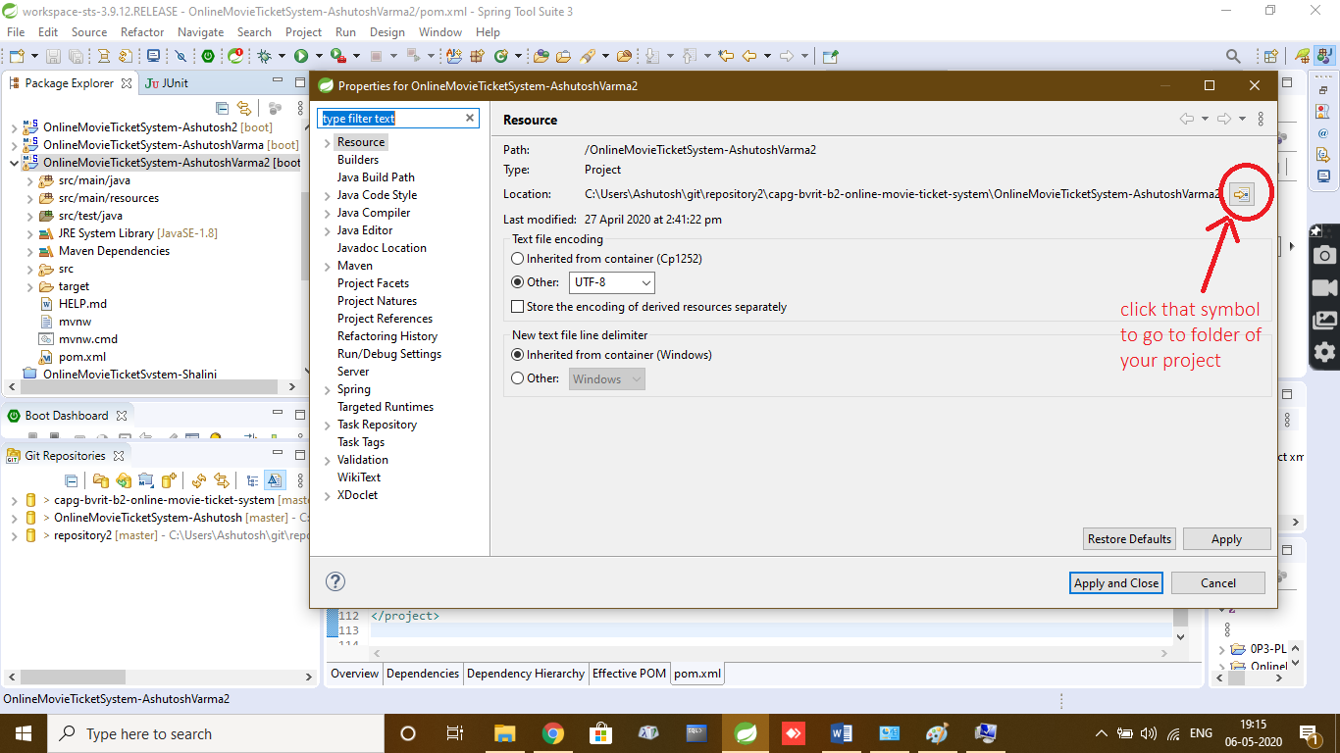

1. Once you click that symbol then system will take you to the project folder. Open that project folder then you will be seeing all your project files as shown

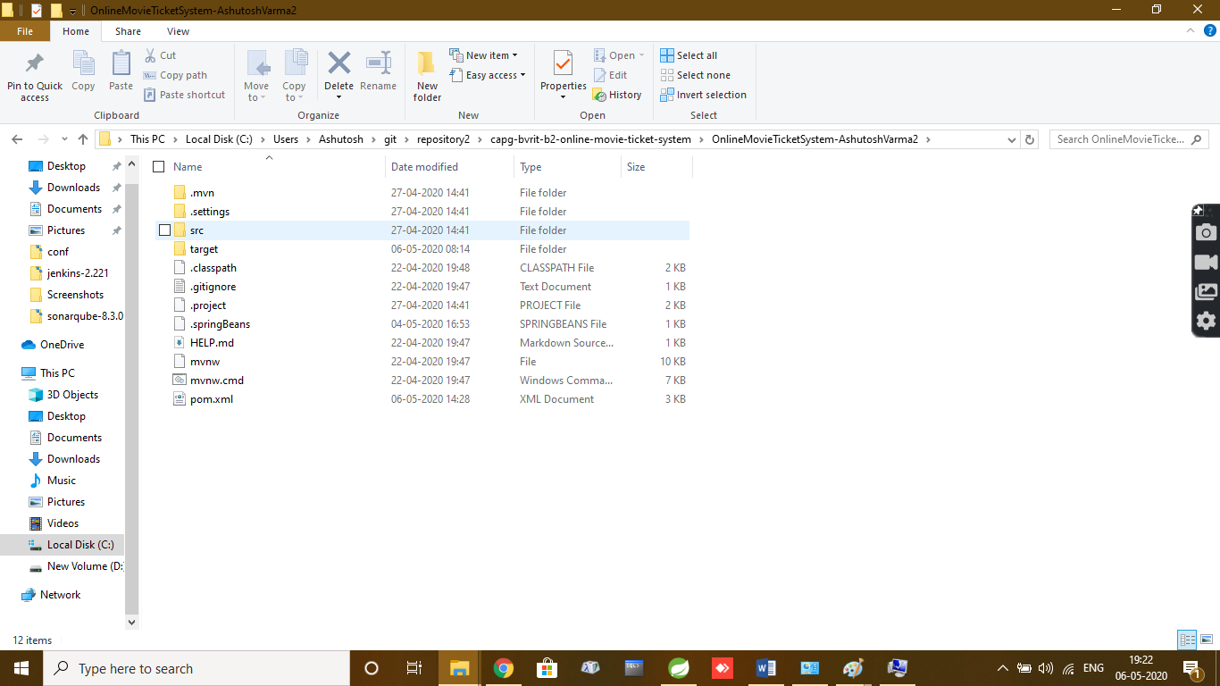

1. On the top of the path select the path and click backspace button on the keyboard and type cmd as shown.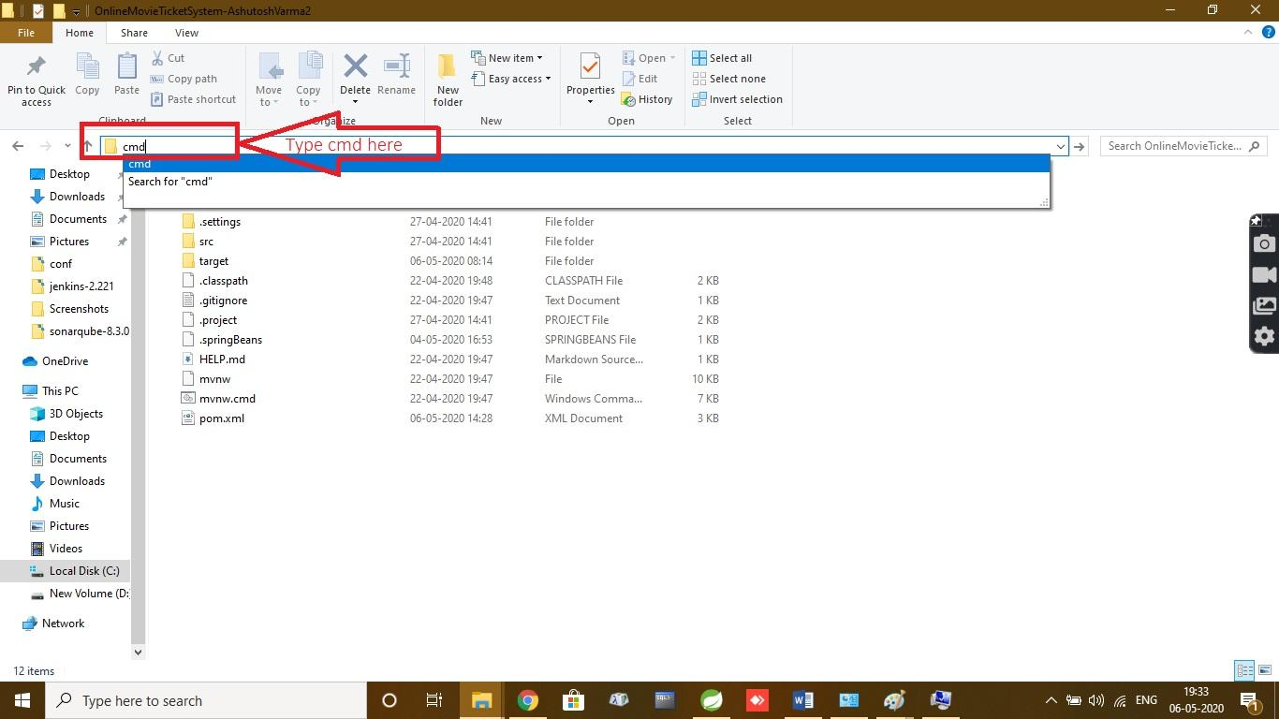
2. Once command prompt opens, then type as “mvnsonar:sonar” and hit enter. It takes 2-5 minutes. You should see the build success as shown in fig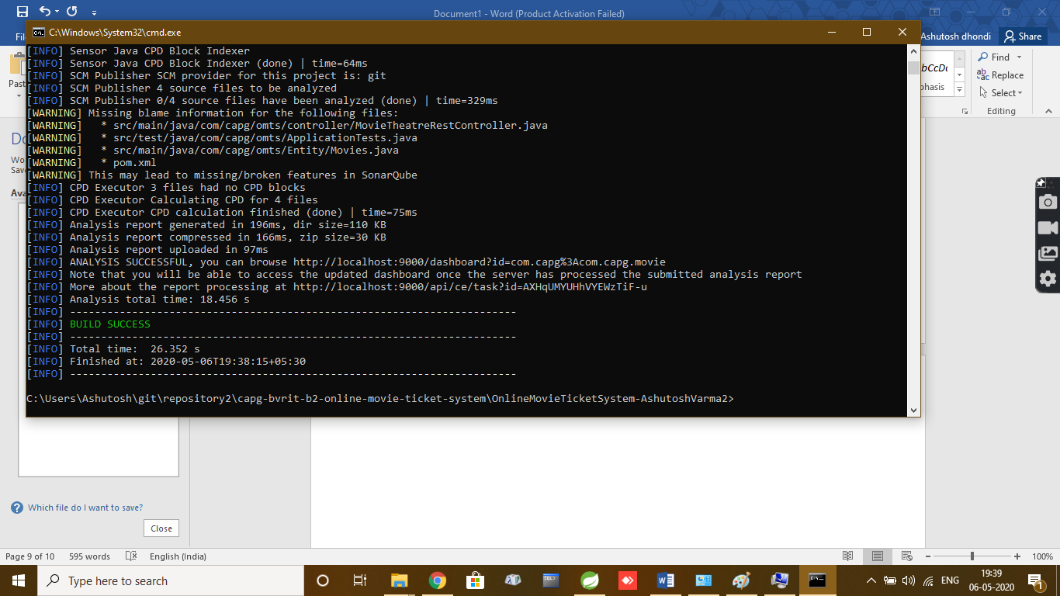
3. Now open the sonarqube you can open in 2 ways the port number which is given in the cmdprompt(Above the build success there is analysis successful in that line there is port number copy that port no and paste in the browser url

(OR)

After Build success simply open localhost:9000 and refresh it.

Scroll down to see the output

